F14076083 魏湧致

3.6

(a) P(X>200) = $\int_{200}^{∞}{\frac{20000}{{(x+100)}^{3}}} dx$ = $-\frac{10000}{{(x+100)}^{2}}{ |}_{200}^{∞}$ = $\frac{10000}{90000}$ = $\frac{1}{9}$

(b) P(80<X<120) = $\int_{80}^{120}{\frac{20000}{{(x+100)}^{3}}} dx$ = $-\frac{10000}{{(x+100)}^{2}} |_{80}^{120}$ = $\frac{10000}{{180}^{2}}-\frac{10000}{{220}^{2}}$ ≈ 0.10203

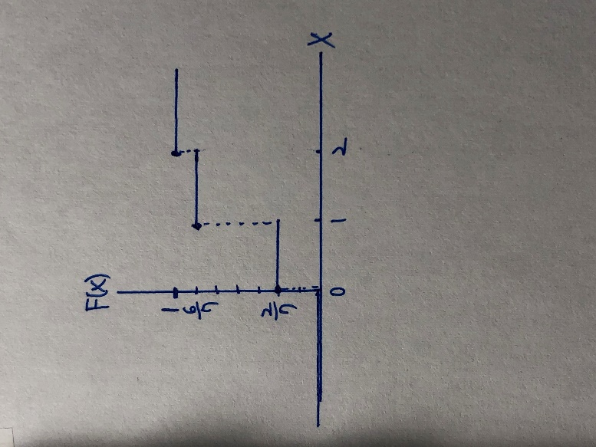

3.16

$$F\left(x\right)=\left\{\begin{aligned}0, whne x<0 \\ 2/7, when 0≤x<1 \\ 6/7, &when 1≤x<2 \\ 1, &when x≥2\end{aligned}\right.$$

3.24

f(x) = $\frac{\left({5 \atop x}\right)\left({2+3 \atop 4-x}\right)}{\left(\frac{5+2+3}{4}\right)}$ = $\frac{\left({5 \atop x}\right)\left({5 \atop 4-x}\right)}{\left(\frac{10}{4}\right)}$,x=0,1,2,3,4

3.36

(a) P(X<0.5) = $\int_{0}^{0.5}{2(1-x)} dx$ = 2x- $x^{2}{ |}_{0}^{0.5}$ = 0.75

(b) P(X>0.4) = 2x- $x^{2}{ |}_{0.4}^{1}$ = 0.36

(c) P(X<0.7 | X≥0.5) = $\frac{P(0.5≤X<0.7)}{P(X≥0.5)}$ = $\frac{2x-x^{2}{ |}_{0.5}^{0.7}}{2x-x^{2}{ |}_{0.5}^{1}}$ = $\frac{0.16}{0.25}$ = $\frac{16}{25}$

3.40

(a) g(x) = $\int_{0}^{1}{\frac{2}{3}(x+2y)} dy$ = $\frac{2}{3} (xy+y^{2}){ |}_{y=0}^{y=1}$ = $\frac{2}{3} (x+1)$, for 0≤x≤1 ,

and g(x) = 0 elsewhere

(b) h(y) = $\int_{0}^{1}{\frac{2}{3}(x+2y)} dx$ = $\frac{2}{3} (\frac{x^{2}}{2}+2xy){ |}_{x=0}^{x=1}$ = $\frac{2}{3} (\frac{1}{2}+2y)$, for 0≤y≤1 ,

and h(y) = 0 elsewhere

(c) P(X< $\frac{1}{2}$) = $\int_{0}^{1/2}{\frac{2}{3} (x+1)} dx$ = $\frac{2}{3} (\frac{x^{2}}{2}+x){ |}_{x=0}^{x=1/2}$ = $\frac{5}{12}$

3.50

(a)

|  |  |  |
| --- | --- | --- |
| x | 2 | 4 |
| g(x) | 0.1+0.2+0.1 = 0.4 | 0.15+0.3+0.15 = 0.6 |

(b)

|  |  |  |  |
| --- | --- | --- | --- |
| Y | 1 | 3 | 5 |
| h(y) | 0.1+0.15 = 0.25 | 0.2+0.3 = 0.5 | 0.1+0.15 = 0.25 |